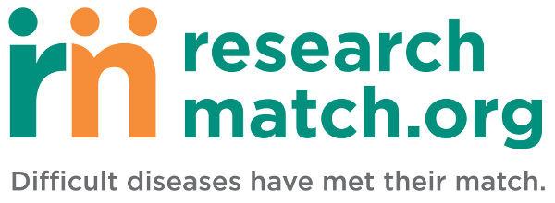

ResearchMatch.org: You may be a good match for this study!
info@researchmatch.org
To: [email address]

A research team with Rutgers University, The State University of New Jersey, believes you might be a good match for the following study:
Researchers at Rutgers University are studying the stress related to caregiving for an individual with a chronic disease. Primary caregivers are family and/or friends who provide a majority of the care required for an individual suffering from a chronic disease. The goal of the study is to better understand the unique stress that caregivers experience in domains both in and outside of the care environment, along with cognitive effects of stress that may arise while providing care. Findings from this study will be used to develop programs and policies that help caregivers.
You may be eligible for this study if: 1) You are the primary family member or friend responsible for the care or management of care for an individual with a chronic disease or share the responsibility equally with another family member or friend. 2) The care-recipient must not live in a nursing home or assisted living facility. 3) You are over the age of 40-years-old.
The study will consist of one study session that will last approximately 90 minutes. The session will take place at either Rutgers’ campus in Newark or New Brunswick. The research team can also conduct the session at the participant’s home if more convenient or via Skype. Participants will receive a $20 Amazon gift certificate on completion of the interview.
Please consider clicking “Yes, I’m interested” if you or someone you know may be eligible for this study. This will allow the research team to contact you to answer any questions you may have.
If you are interested in this study and having the research team contact you directly, please select the "Yes, I'm interested" link below. By clicking the "Yes, I'm interested" link, your contact information will be released to the research team. If you select the "No, thanks." link or do not respond to this study message, your contact information will not be released to the research team.
Yes, I'm interested!
No, thanks.
Thank you for your interest in ResearchMatch.
ResearchMatch Disclaimer
You are receiving this email message since you have registered in the ResearchMatch registry. Should you wish to edit your profile please click here to login and update your profile.
ResearchMatch is a free and secure tool that helps match willing volunteers with eligible researchers and their studies at institutions across the country. ResearchMatch is only providing a tool that allows you to be contacted by researchers about their studies. ResearchMatch therefore does not endorse any research, research institution, or study. Any recruitment message that you may receive about a study does not mean that ResearchMatch has reviewed the study or recommends that you consider participating in this study.
If you no longer wish to be part of ResearchMatch, please remove your account by clicking here.

